Memory Seat Module - Driver C1

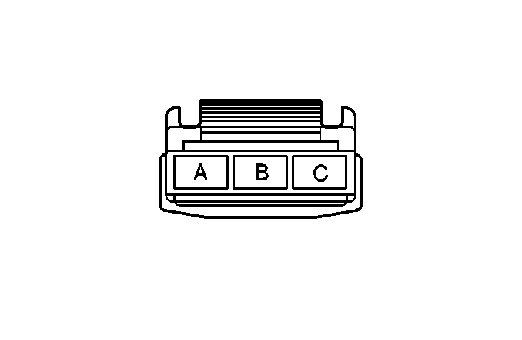
Connector Part Information |  | - 12020557  - 3-Way F M/P 480 (BLK)
Pin | Wire Color | Circuit No. | Function
A | ORN | 2740 | Battery Positive Voltage
B | BLK | 1350 | Ground
C | ORN | 3540 | Battery Positive Voltage

Memory Seat Module - Driver C2

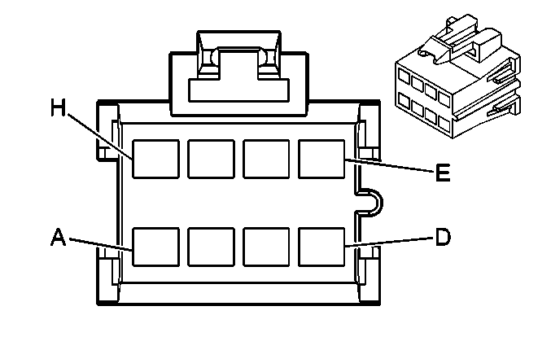
Connector Part Information |  | - 15332153  - 8-Way F GT 150 (BLK)
Pin | Wire Color | Circuit No. | Function
A | DK GRN | 286 | Driver Seat Front Vertical Motor Up Control
B | DK BLU | 287 | Driver Seat Front Vertical Motor Down Control
C | LT BLU | 283 | Driver Seat Rear Vertical Motor Down Control
D | YEL | 282 | Driver Seat Rear Vertical Motor Up Control
E | LT GRN | 284 | Driver Seat Horizontal Motor Rearward Control
F | TAN | 285 | Driver Seat Horizontal Motor Forward Control
G | LT BLU | 277 | Driver Seat Recline Motor Rearward Control
H | LT GRN | 276 | Driver Seat Recline Motor Forward Control

Memory Seat Module - Driver C3

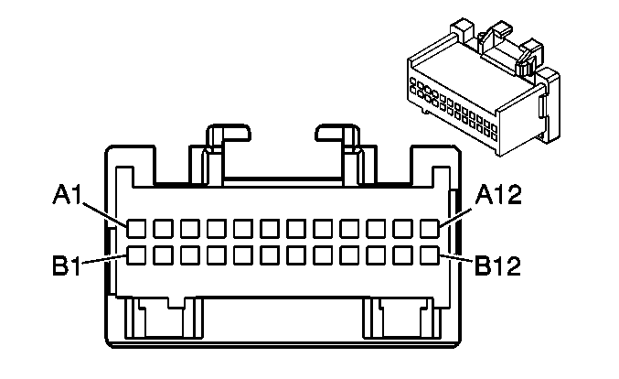
Connector Part Information |  | - 12110206  - 24-Way F M/P 100 (LT BLU)
Pin | Wire Color | Circuit No. | Function
A1 | YEL | 2080 | Low Reference
A2 | ORN | 940 | 5 Volt Reference
A3 | BLK | 1062 | Driver Seat Lumbar Vertical Position Sensor Signal
A4 | YEL | 1063 | Driver Seat Lumbar Horizontal Position Sensor Signal
A5-A6 | -- | -- | Not Used
A7 | ORN | 840 | 5 Volt Reference
A8 | BLK | 850 | Ground
A9 | WHT/BLK | 570 | Driver Seat Recline Motor Position Sensor Signal
A10 | DK GRN | 569 | Horizontal Seat Motor Position Sensor Signal
A11 | TAN | 568 | Rear Vertical Seat Motor Position Sensor Signal
A12 | BRN/WHT | 557 | Front Vertical Seat Motor Position Sensor Signal
B1 | YEL/BLK | 2079 | Heated Seat Thermistor Signal
B2 | BLK | 950 | Low Reference
B3 | PPL | 767 | Driver Seat Lumbar Motor Down Control
B4 | TAN | 768 | Driver Seat Lumbar Motor Up Control
B5-B6 | -- | -- | Not Used
B7 | RED/WHT | 2077 | Heated Seat Back Element Supply Voltage
B8 | RED/WHT | 2077 | Heated Seat Cushion Element Supply Voltage
B9 | DK BLU | 611 | Driver Seat Lumbar Motor Forward Control
B10 | PNK | 610 | Driver Seat Lumbar Motor Rearward Control
B11-B12 | -- | -- | Not Used

Memory Seat Module - Driver C4

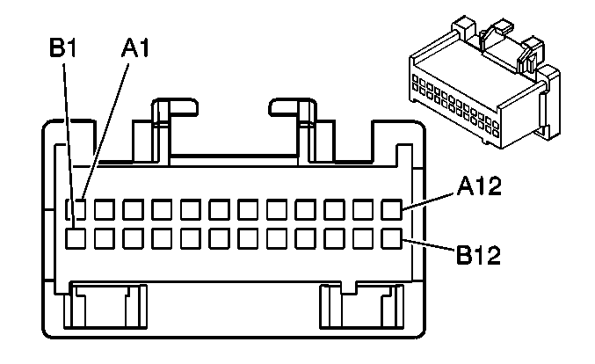
Connector Part Information |  | - 12110088  - 24-Way F M/P 100 (LT GRY)
Pin | Wire Color | Circuit No. | Function
A1-A3 | -- | -- | Not Used
A4 | DK GRN/WHT | 1270 | Power Seat Recline Rearward Switch Signal
A5 | GRY/BLK | 1269 | Power Seat Recline Forward Switch Signal
A6 | LT GRN | 1523 | Power Seat Horizontal Rearward Switch Signal
A7 | TAN | 1522 | Power Seat Horizontal Forward Switch Signal
A8 | LT BLU | 1521 | Power Seat Rear Vertical Down Switch Signal
A9 | YEL | 1519 | Power Seat Rear Vertical Up Switch Signal
A10 | DK BLU | 1520 | Power Seat Front Vertical Down Switch Signal
A11 | DK GRN | 1518 | Power Seat Front Vertical Up Switch Signal
A12 | LT GRN | 2078 | Heated Seat Cushion Element Control
B1 | -- | -- | Not Used
B2 | BRN/WHT | 1048 | SCM (Seat) Class 2 Serial Data
B3 | -- | -- | Not Used
B4 | GRY | 961 | Battery Positive Voltage
B5 | RED/WHT | 240 | Battery Positive Voltage
B6-B7 | -- | -- | Not Used
B8 | TAN/WHT | 1067 | Driver Seat Lumbar Down Switch Signal
B9 | BRN/WHT | 1066 | Driver Seat Lumbar Up Switch Signal
B10 | RED | 1065 | Driver Seat Lumbar Rearward Switch Signal
B11 | PNK | 1064 | Driver Seat Lumbar Forward Switch Signal
B12 | LT GRN | 2078 | Heated Seat Back Element Control

