In-Line Connector C100
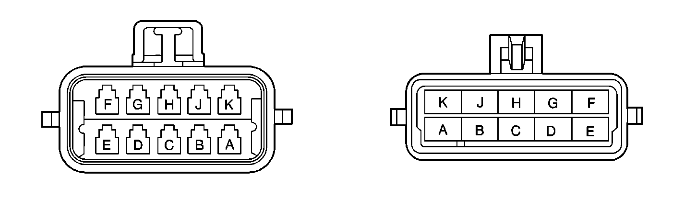

Pin | Wire Color | Circuit No. | Function
A | PNK | 639 | Fused Feed Input
B | DK GRN/WHT | 459 | A/C Compressor Relay Control
C | DK GRN | 59 | A/C Compressor Clutch Solenoid Feed
D | GRY | 596 | (V8 VIN G) (+NW9) Reference Voltage Feed - 5 Volt Reference
E | DK BLU | 417 | (V8 VIN G) (+NW9) Throttle Position Sensor Signal
F | BRN | 86 | (V6 VIN K) Brake Pedal Switch Output
G | PNK | 239 | Fused Input Feed
H | DK BLU | 473 | Coolant Fan Relay Control
J | DK GRN | 335 | Coolant Fan Relay Control
K | BLK | 452 | (V8 VIN G) (+NW9) Sensor Return
In-Line Connector C101
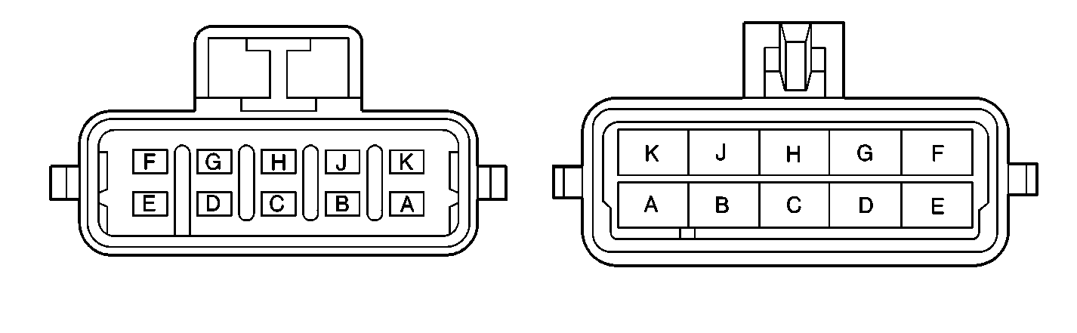

Pin | Wire Color | Circuit No. | Function
A | YEL/BLK | 625 | Vehicle Anti-Theft System Starter Enable Relay Output - Coil
B | BLK/WHT | 451 | (V6 VIN K) Ground
B | PNK | 839 | (V8 VIN G) Fused Input Feed
C | BRN | 436 | (V8 VIN G) Idle Speed Control Motor Relay Output-Coil
D | DK GRN/WHT | 465 | Fuel Pump Relay Feed - Coil
E | PNK | 439 | Fused Input Feed
F | -- | -- | Not Used
G | ORN | 340 | Fused Input Feed
H | BLK/WHT | 451 | Ground
J | PPL/WHT | 1035 | (V6 VIN K) Starter Relay Feed-Coil
K | DK GRN | 220 | (V6 VIN K) Vehicle Anti-Theft System Signal-Starter Inhibit
K | GRY/BLK | 1687 | (V8 VIN G) (+NW9) Ignition Retard Signal
In-Line Connector C105
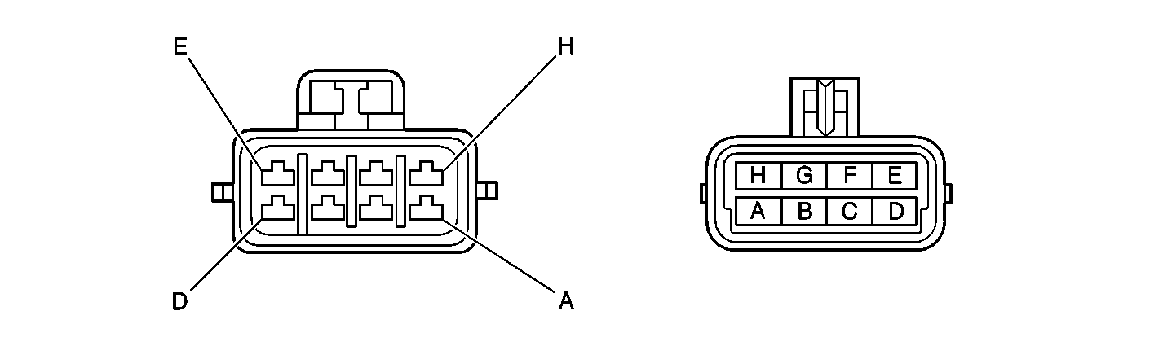

Pin | Wire Color | Circuit No. | Function
A | PPL/WHT | 1572 | (V6 VIN K) (M30, - NW9) Traction Control System Indicator Lamp Output - Failure
B | PNK | 539 | Fused Output - Ignition
C | BRN/WHT | 1571 | (V6 VIN K) (M30, - NW9) Traction Control System Switch Signal
D | ORN/BLK | 463 | (V6 VIN K) (+ NW9) Traction Control System Signal - Torque Desired
D | DK GRN | 83 | (V8 VIN G) Cruise Control Signal-Disengage
E | -- | -- | Not Used
F | TAN/BLK | 464 | (V6 VIN K) (+ NW9) Traction Control System Signal - Torque Delivered
F | WHT | 85 | (V8 VIN G) Cruise Control Indicator Lamp Output
G | WHT | 121 | (+ NW9) Tachometer Signal
H | ORN | 1440 | (V8 VIN G) Fused Input Feed

