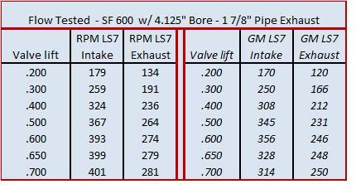

RPM motors $1095 + core

Flow Data: @ 4.125" Bore Plate Superflow 600

 | LS7  Intake | LS7 Exhaust | PRC 265cc  LS7 Intake | PRC LS7 Exhaust
.200 | 161 | 114 | 169 | 119
.300 | 227 | 171 | 248 | 179
.400 | 291 | 193 | 308 | 211
.500 | 330 | 203 | 351 | 224
.600 | 351 | 209 | 383 | 235
.650 | 353 | 204 | 388 | 241
.700 | 353 | 209 | 393 | 246

Texas speed $1799 outright

These flow numbers are tested with correctly sized bore adapter.

Lift | CFM Intake | CFM Exhaust no pipe | CFM Exhaust with pipe
.200 | 174 | 120 | 127
.300 | 256 | 164 | 180
.400 | 312 | 200 | 217
.500 | 352 | 222 | 240
.600 | 384 | 234 | 260
.650 | 395 | 239 | 268
.690 | 396 | 242 | 273

Lingenfelter $1295 + core

