Chili’s MWC 3rd Annual St. Jude’s Children’s Hospital AUTO SHOW

SATURDAY SEP 19, 2009
Show starts 1030AM
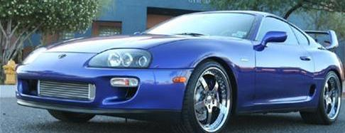
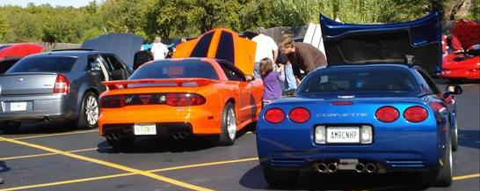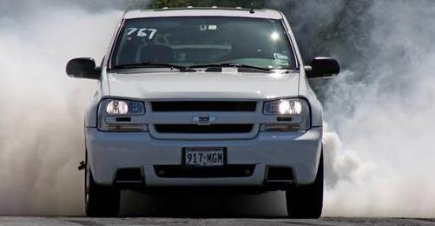

Entry is $20.00
Please contact Christopher Heskey 405-513-2010 or Kate (Chili’s MWC manager) @ 869-0670

